WEB TECHNOLOGY AND ITS APPLICATIONS ASSGINMENT- 04

MANISHA R

1JT18IS034

6th SEM ISE

CHALLENGE PROGRAM

<!DOCTYPE HTML>

<html>

<head><title>Program-4</title></head>

<body>

<script type="text/javascript">

var str = prompt("Enter the Input", "");

if (!(isNaN(str))) //isNaN means is Not a Number

{

var num, rev = 0,remainder;

num = parseInt(str);

while (num != 0)

{

remainder = num % 10;

num = parseInt(num / 10);

rev = rev * 10 + remainder;

}

const product = str*rev;

alert("Reverse of " + str + " is " + rev + " and the product is " + product );

}

else

{

str = str.toUpperCase();

function vowels(string){

var vowels = 'AEIOUaeiou';

var count = 0;

for(i=0; i<string.length; i++){

if(vowels.indexOf(string[i]) !==-1){

count+=1;

}

}

return count;

}

n = vowels(str)

alert("The given string" + " '" + str +"' has " +n+ " number of vowles" )

}

</script>

</body>

</html>

**Output 1: Integer Value test**

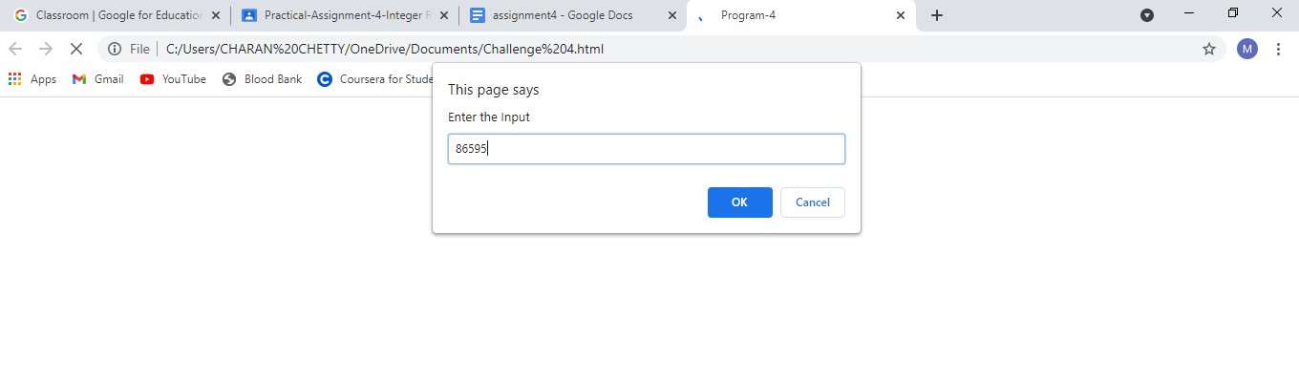

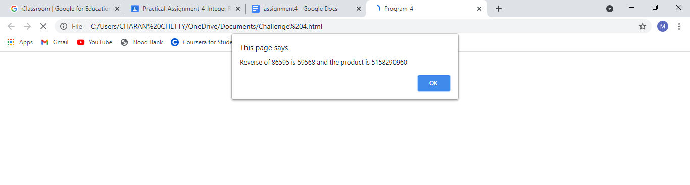

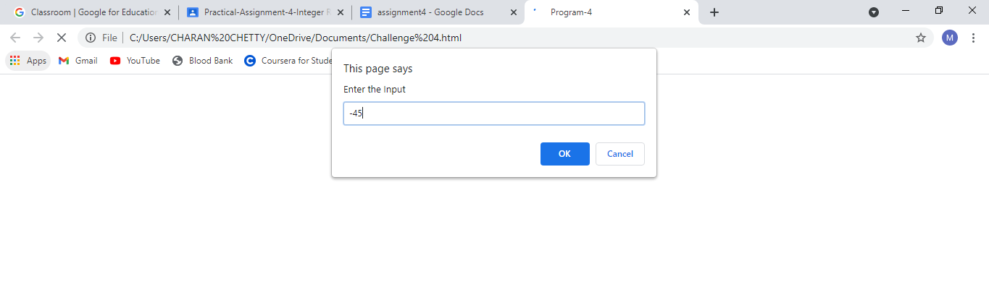

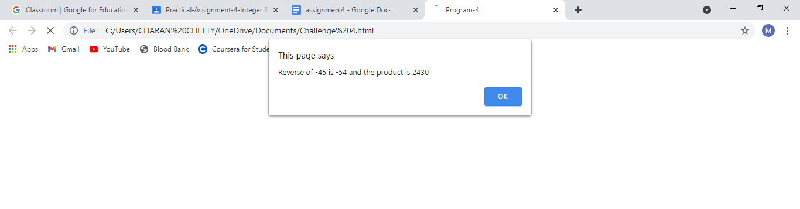**Output 2: String Value Test**

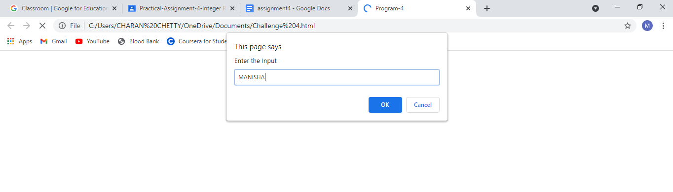

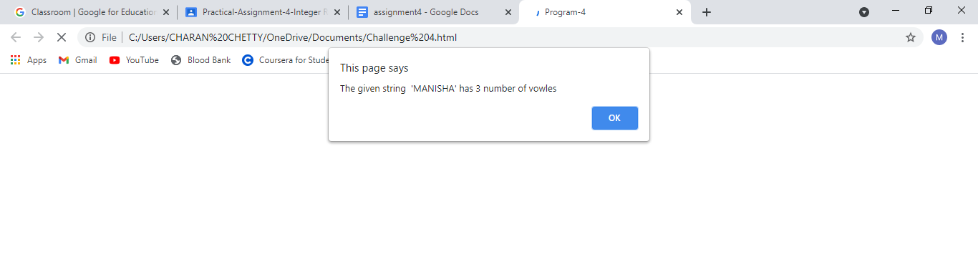

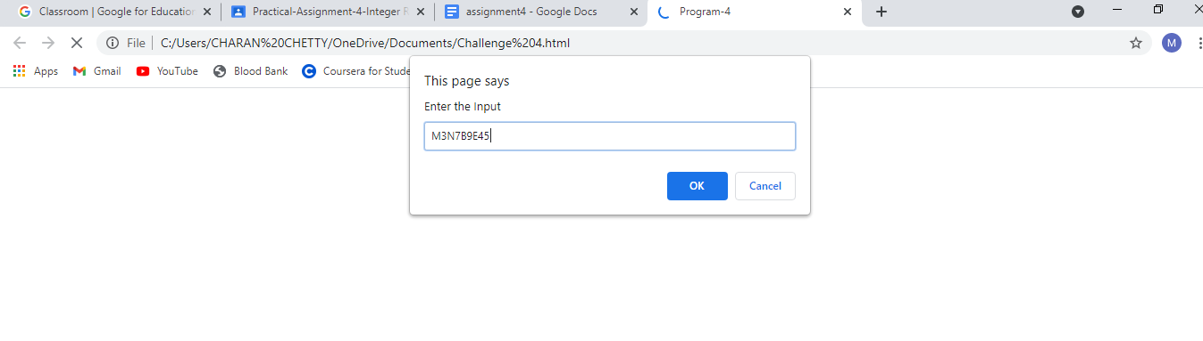

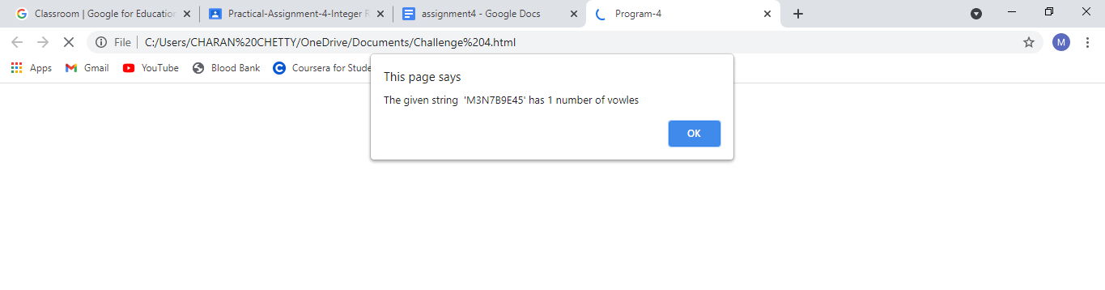

TEST CASES:

|  |  |  |  |
| --- | --- | --- | --- |
| Test No. | Test Case | Expected Output | Output Obtained |
| 1 | Integer Value: 86595  Text Value: MANISHA | Reverse: 59568  Product: 51518290960  No of vowels: 3 | Reverse: 59568  Product: 51518290960  No of vowels: 3 |
| 2 | Negative Integer value: -45    Text Value:Intelligence | Reverse: -54  Product: 2430  No of vowels: 5 | Reverse: -54  Product: 2430  No of vowels: 5 |
| 3 | Integer Value: 1221  Alpha numerical value: MAN4893 | Reverse: 1221  Product: 1490841  No of vowels: 1 | Reverse: 1221  Product: 1490841  No of vowels: 1 |
| 4 | Integer Value: 010010  Non vowel string:GLYPH | Reverse: 010010  Product: 1020010  No of vowels: 0 | Reverse: 1001  Product: 1020010  No of vowels: 0 |
| 5 | Decimal value: 59.85  Alphanumeric value: B3H6G7 | Reverse: 58.95  Product: 3528.1575  No of vowels: 0 | Reverse: 95  Product: 5685.75  No of vowels: 0 |